PROJECT TITLE : How to Create a YouTube Ad Campaign

TEAM MEMBERS:

TEAM LEADER: LOKESH K

NM ID : 1BD30691AFF74A1982445CC2F439AC77

TEAM MEMBER 1: KIRUTHIKAA S

NM ID : 6E0127AC21D6B82B2054BB7E73B7E36D

TEAM MEMBER 2: SRUTHIKA C

NM ID : 23BC86CC08843049C2641B9DB1CE90C2

TEAM MEMBER 3: RANGARAJ S

NM ID : 2039397ECE03FCAAD1B4B3E7C0E8DCA2

DRIVE LINK : <https://drive.google.com/drive/folders/1moDUWGn7qPT_WKx8uJ9VHkA0QLorcAwM>

SUBMISSION DATE: 23/10/2023

Project Details:

Creating a YouTube ad campaign is a multi-step process that allows businesses to promote their products or services to a vast online audience. Here are the key steps:

Google Ads Account Setup: Begin by setting up a Google Ads account if you don't have one. This is the platform through which you'll create and manage your YouTube ad campaigns.

Campaign Goals: Define clear objectives for your campaign. Decide if you want to increase website traffic, generate leads, boost brand awareness, or drive sales. Your goals will determine your campaign's structure and settings.

Audience Targeting: Identify your target audience based on demographics, interests, and behaviors. YouTube offers precise targeting options to ensure your ads reach the right viewers.

Ad Creation: Develop compelling video ads that capture viewers' attention within the first few seconds. Ensure your ad's message aligns with your campaign goals and audience.

Budget and Bidding: Set a daily or lifetime budget for your campaign. You can choose between different bidding strategies, such as cost-per-view (CPV) or cost-per-click (CPC), depending on your goals.

Ad Placement: Specify where your ads will appear on YouTube, including in-stream ads that play before or during videos, or video discovery ads that appear in search results and related videos.

Ad Scheduling: Decide when your ads will run to maximize their effectiveness. You can schedule them to run at specific times or continuously.

Monitoring and Optimization: Regularly review your campaign's performance metrics, like click-through rate (CTR) and conversion rate. Make adjustments to improve results, such as refining targeting or adjusting bids.

Testing and Experimentation: Test different ad variations to see which ones perform best. A/B testing can help you refine your messaging and creative elements.

Campaign Launch: Finally, launch your YouTube ad campaign, and monitor it closely. Continuously refine your strategy to achieve your advertising goals and reach your target audience effectively.

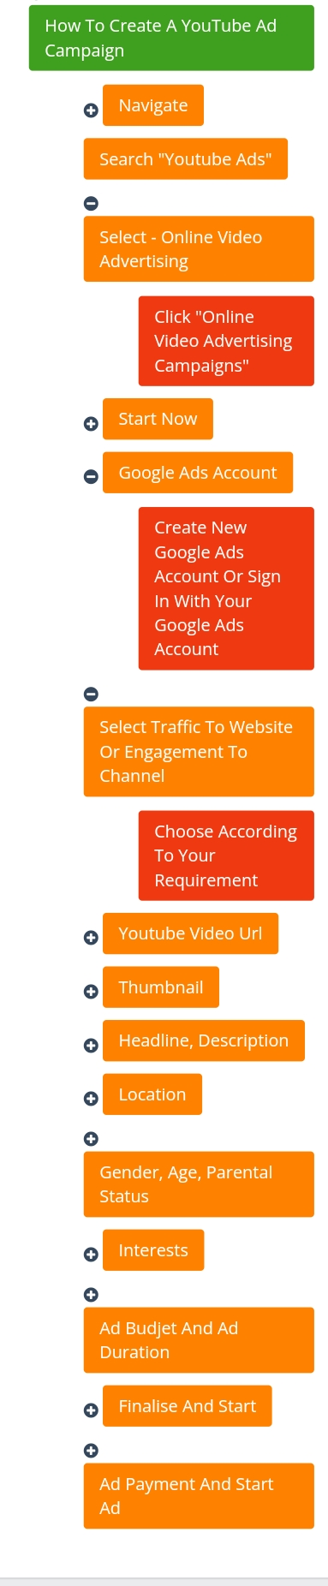

The images and videos are attached in the drive link its clearly understand the flow compare with video